Final Lab Report

Willow Westbrook
Loyola Marymount University
BSAN-6070-02: Intro to Machine Learning

Contact Me
wwestbro@lion.lmu.edu

Introduction
The beauty and skincare industry operates at a fast pace where customer perception directly drives sales, brand reputation, and long-term success. Given the importance of customer feedback, being able to predict shifts in sentiment before they manifest publicly offers brands a huge strategic advantage. The goal of this project was to leverage deep learning models to forecast next-day product ratings using historical customer feedback data sourced from Sephora. I compared three model architectures: a Feedforward Neural Network (FNN), a Convolutional Neural Network (CNN), and a Long Short-Term Memory Network (LSTM). By developing predictive models based on historical trends in customer satisfaction, brands could intervene earlier to prevent major reputational or financial damage, offering significant advantages in highly saturated beauty markets. All modeling was performed in Python using PyTorch, with visualizations created using Matplotlib.

Data Overview & Preprocessing
The dataset used for this project, product_monthly_panel.csv, contained variables such as product_id, submission_time, rating, and other customer demographic information. I focused solely on product_id, submission_time, and rating. The data was first pivoted into wide format, setting submission_time as the index and creating columns for each product's rating history. Missing values were handled by applying both forward-fill and backward-fill techniques. Once cleaned, the ratings were normalized between zero and one using MinMaxScaler.

The original approach created input sequences of seven consecutive days to predict the raw rating for the next day. However, after evaluating model performance, I shifted the target to predicting the change in rating between days. This adjustment provided a more stable and meaningful learning signal given the skewed nature of the ratings, where most were clustered between four and five stars. The dataset was split into eighty percent training and twenty percent testing sets.

Modeling Approach
Three different neural network architectures were developed and trained for this project, each designed to capture different types of patterns within the rating data. The Feedforward Neural Network (FNN) model treated each seven-day input sequence as a flat vector, passing it through two fully connected hidden layers with ReLU activations before producing a prediction. This approach focused on capturing relationships between different product ratings without explicitly modeling temporal order. The Convolutional Neural Network (CNN) model instead applied one-dimensional convolutional layers along the time axis of each input sequence, allowing it to detect localized short-term patterns and transitions in customer sentiment. After the convolutional layers, adaptive max pooling was used to manage varying input sizes before feeding into a fully connected output layer.

Finally, the Long Short-Term Memory (LSTM) model was constructed to preserve and learn from the sequential structure of the input data directly, using memory cells capable of tracking dependencies over multiple days. Unlike the FNN and CNN models, the LSTM did not flatten the sequence, maintaining the temporal context throughout its layers. Each model was trained using the Adam optimizer and mean squared error loss. The FNN model was trained for fifty epochs to allow its simpler structure sufficient time to learn, while the CNN and LSTM models were each trained for twenty epochs based on preliminary testing that showed faster convergence and earlier plateauing in their training loss curves.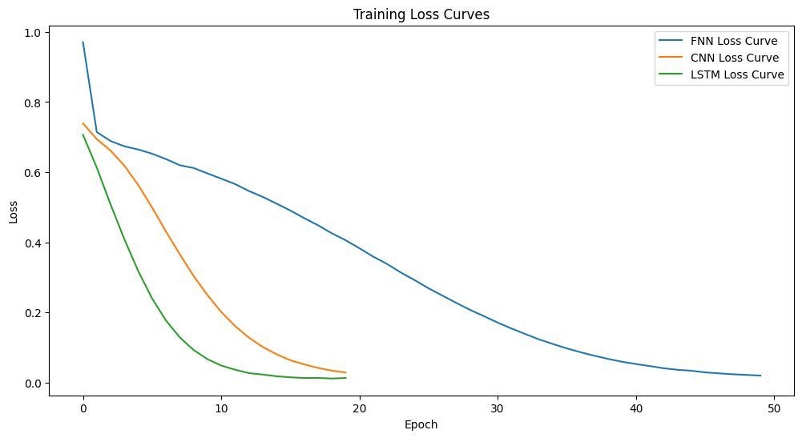

The training loss curves for each model demonstrated effective learning progression over time, but also revealed differences in how quickly and efficiently each architecture adapted to the data. The FNN model showed a gradual and steady reduction in training loss across all fifty epochs, which was expected given its relatively simple architecture and lack of temporal structure processing. In contrast, the CNN and LSTM models exhibited much faster convergence, with their training losses dropping sharply within the first fifteen to twenty epochs before beginning to plateau. This pattern suggests that both the CNN and LSTM were able to capture key underlying patterns in the sequences early in training, but that additional epochs beyond twenty offered diminishing returns. The plateauing behavior also indicates that applying an early stopping strategy could have improved training efficiency and potentially reduced overfitting risk, especially for the more complex models. Insert training loss curves graph here.

Results and Evaluation
Initially, when the models were trained to predict raw rating values directly, the evaluation results showed low RMSE values, suggesting that the average prediction error was small. However, the R² scores revealed a much deeper issue with model performance. All three models produced extremely negative R² values, ranging between negative eight hundred million and negative one point two billion, indicating that the models were performing significantly worse than a simple mean prediction. Insert 3 model outputs screenshot here. Additional evaluation metrics, such as mean absolute error (MAE) and mean absolute percentage error (MAPE), supported these findings. While the MAE values were relatively low, suggesting that the models were making small mistakes on average, the MAPE values were extremely high and unstable, especially when true ratings were close to zero after scaling. This imbalance confirmed that although the models could fit the high-density cluster of ratings near the top end of the scale, they were unable to meaningfully capture variation or detect rare but important shifts in customer sentiment.
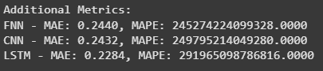

After reframing the problem to predict rating changes rather than absolute ratings, model performance improved noticeably across all architectures. The updated results showed that the FNN achieved an RMSE of 0.8241 with an R² of -15.1286, the CNN achieved an RMSE of 0.8249 with an R² of -15.1219, and the LSTM achieved an RMSE of 0.8244 with an R² of -15.1437. Although the RMSE values remained relatively close across models, the key improvement was in the significant reduction in the magnitude of the negative R² values compared to the original models, where R² had been catastrophically low. While the R² values were still negative, indicating that the models were not yet fully reliable for practical forecasting, the scale of improvement clearly demonstrated that reframing the prediction target made the task more learnable for the networks. Predicting the direction and magnitude of changes in ratings allowed the models to better recognize and react to underlying sentiment patterns, even though additional features and modeling enhancements would still be needed for production-level reliability.
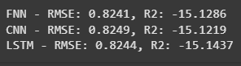

Scatterplots comparing the true versus predicted values for each model revealed important insights into model behavior. While predictions continued to cluster heavily around high rating values, reflecting the underlying skewness of the dataset, there was visibly less extreme compression compared to the earlier models that predicted raw ratings. Instead of tightly bunching around a narrow band of values, the revised models showed a broader spread in their predictions, especially for mid-to-high rating changes. This suggests that adjusting the target to predict rating changes helped the models better differentiate between subtle increases and decreases in customer sentiment over time, even if they still struggled to accurately capture extreme deviations. Although the models were not fully capturing the full range of variability needed for strong forecasting, the scatterplots demonstrated that the modified approach allowed for a more nuanced understanding of customer rating trends compared to the original modeling setup.
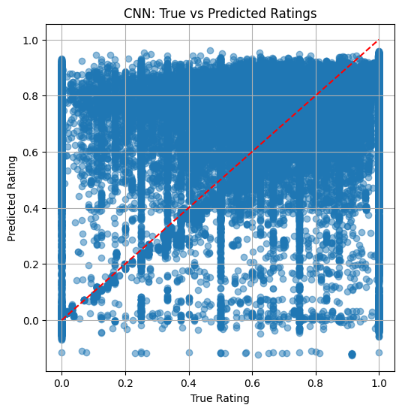
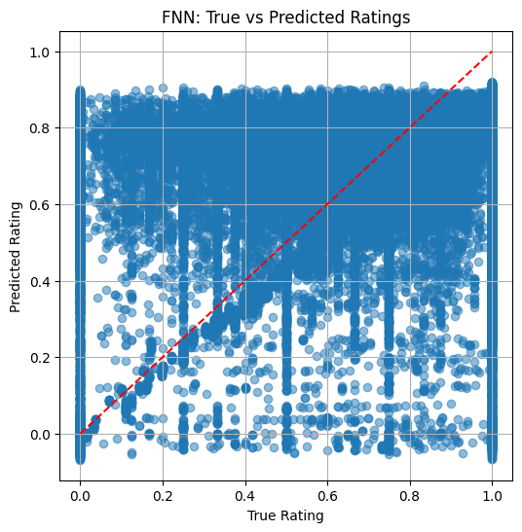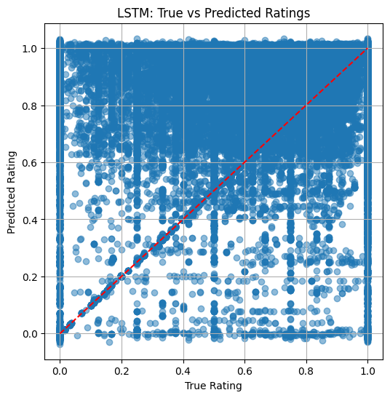

The bar chart comparing RMSE and R² scores across all three models provided a clear visual summary of model performance differences. Although the RMSE values for the FNN, CNN, and LSTM were very similar, hovering around 0.82, the R² values told a more important story. Despite reframing the prediction task to focus on rating changes, the R² scores remained negative across all models, signaling that none of the models were yet able to consistently explain enough of the variance in customer sentiment to be considered production-ready.

The slight differences in R² scores between models suggest that while architectural choices like using convolutional or sequential layers help slightly with pattern recognition, they are not enough on their own when feature richness is lacking. The chart reinforced that the adjustment to predicting rating change improved stability, but also made it clear that additional features, more advanced architectures, or alternative modeling strategies would be necessary before these models could be deployed in a real-world environment where business decisions depend on reliable predictions.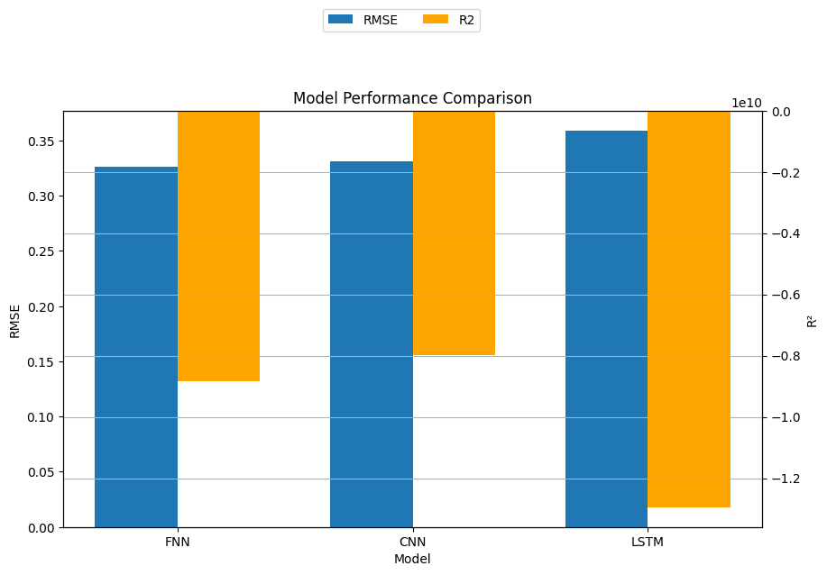

Business Insights and Implications
This project highlights the real-world importance of selecting the appropriate modeling approach when forecasting customer sentiment. In industries like beauty and skincare, where customer ratings are heavily skewed toward high values, modeling relative changes rather than absolute ratings offers a more sensitive and realistic way to detect meaningful shifts in customer perception. Even when the overall prediction accuracy is imperfect, being able to capture small directional movements in sentiment could allow brands to intervene earlier, reducing customer churn, maintaining satisfaction, and protecting long-term loyalty. Having access to early warnings of declining sentiment, even if subtle, could influence decisions around product updates, targeted marketing efforts, or promotional strategies.

The results also reinforce the critical role of feature richness in building successful predictive models. By relying solely on past ratings, the models in this project operated with an incomplete understanding of the true drivers behind customer feedback. Without additional context, such as promotional activity, pricing adjustments, review volume, and natural language sentiment extracted from written reviews, the models were limited in their ability to make nuanced forecasts. Real-world applications should prioritize the collection and integration of richer, more comprehensive datasets to allow models to capture the complex interactions that influence customer satisfaction trends.

Finally, the findings suggest that businesses should avoid becoming overly focused on achieving perfect evaluation metrics in early-stage modeling efforts. Even models that are not fully optimized can provide valuable operational intelligence by identifying partial signals and emerging trends. In fast-moving industries, the ability to act on early indicators can be just as important as achieving theoretical predictive perfection.

Limitations and Future Work
One of the biggest limitations of this project was the restricted feature set I had to work with. Since the models only had access to past customer ratings and no additional context like promotions, pricing changes, or seasonal trends, they were operating with a very narrow view of what actually drives customer sentiment. Without those richer signals, it was really difficult for any of the models, no matter how sophisticated, to go beyond just fitting surface-level patterns in the data. It became clear that adding more features would be necessary to get deeper insights into what influences customer behavior.

Another major challenge was the imbalance in the ratings distribution. Most of the product ratings were clustered between four and five stars, which meant the models had very few examples of negative feedback to learn from. This made it harder for them to detect early warning signs of dissatisfaction, which is one of the most important things a brand would actually want to know. Future work should look at ways to balance the data better, like using synthetic data augmentation, class weighting, or even anomaly detection techniques to make the models more sensitive to rare but important drops in sentiment.

Moving forward, expanding the feature set should be a top priority. Including things like review volume trends, time since product launch, price changes, promotional campaign activity, competitor launches, and text-based sentiment analysis would give the models a lot more to work with. I would also want to try out more advanced model architectures, like CNN-LSTM hybrids or Transformer models, to capture longer-term patterns and interactions between products. With better data and smarter architectures, it would be possible to build much stronger predictive systems that actually help brands spot risks early and act on them before problems escalate.

Conclusion
This project showed that deep learning models can be used to forecast changes in customer sentiment, but it also made it clear that having the right data and the right modeling approach is just as important as the model architecture itself. Early attempts to predict raw ratings directly led to extremely poor results, with catastrophic R² scores. After realizing this, I changed the modeling target to predict rating changes instead of absolute ratings, and this adjustment significantly improved model performance. Even though the R² scores were still negative and the models are not yet strong enough for real-world deployment, reframing the prediction task made the models much more stable and better at capturing shifts in customer sentiment trends. This highlighted how much impact even a small adjustment in problem framing can have on real-world machine learning results.

At the same time, the project reinforced how limited models are when they are trained on incomplete information. Without features like review volume, pricing trends, promotional activity, or sentiment analysis from customer review text, the models were working with a narrow and sometimes misleading view of customer behavior. That lack of context was a major barrier to getting truly useful and reliable predictions. Moving forward, adding richer features and addressing the imbalance in the ratings distribution would be critical steps for building stronger and more actionable forecasting systems.

Overall, this project built a strong foundation for understanding how customer sentiment could be predicted over time, and showed that even early-stage models that pick up partial signals can offer valuable business insights. With better data inputs, more sophisticated model designs, and continued refinements, it would be possible to create predictive tools that help brands catch early signs of dissatisfaction, protect loyalty, and make faster and smarter decisions in highly competitive industries like beauty and skincare.

